# **http://itgroove.net/brainlitter/wp-content/uploads/sites/3/2015/07/Tip.jpgAmino Acids, Polypeptides and Proteins**

A **hydrolysis reaction** is a chemical reaction in which water is a reagent.

## **Introduction**

* Proteins are polymer molecules essential for life.
* Amino acids are the monomers used to make proteins.
* Over 500 amino acids are known, and 20 of them are very important for humans as they are used to make proteins in the human body.
* Plants can manufacture all their required amino acids, but humans can only make 11 of them, and the remaining nine need to be obtained from hydrolysis reactions of proteins they ingest. These amino acids our bodies cannot make are often called the “essential” amino acids, as they must be in your diet.

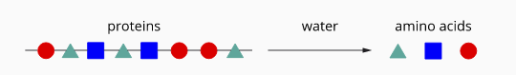

* Proteins have many uses in the human body, including muscle fibres, haemoglobin, hormones, and enzymes.

## **Structure of Amino Acids**

Amino acids contain an amine (-NH2) functional group and a carboxylic acid (-COOH) functional group.

Alpha amino acids consist of an amino [functional group](http://lightbook.pearsonplaces.com.au/CH12_WA/units/CH12_WA-U04/chapters/CH12_WA-U04-13/modules/CH12_WA-U04-13-01/pages/Psec04282015183502175682/topics/Tsec07202015114054773870#sec06092015161702443320), –NH2, a carboxyl functional group, –COOH–, and a hydrogen atom attached to a central carbon called the α-carbon (alpha-carbon). The 20 essential amino acids are all alpha amino acids.

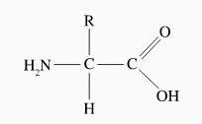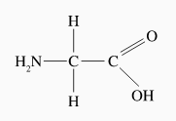

carboxyl group

amino group

alpha carbon

Alpha amino acids have the general formula N2H–CH(R)–COOH

The major difference between one amino acid and another is the group of atoms that comprise the side chain, represented in the general structure as an R-group.

The side chain may be:

**The name, symbol, and structures of all 20 common amino acids shown on the data sheet.**



* non-polar (for example –CH3 in alanine), or
* polar (for example –CH2COOH in aspartic acid).

It may also include functional groups that can behave as:

* proton donors (for example –CH2COOH in aspartic acid), or
* proton acceptors (for example –CH2CH2CH2CH2NH2 in lysine).

Due to their complex nature, chemists rarely name amino acids using the standard IUPAC naming rules instead of the “traditional biochemical name” used for each. For example:

* 2-aminopropanoic acid is called “alanine.”
* 2-amino-3-phenylpropanoic acid is called “phenylalanine.”
* L-2-amino-3-(4-hydroxyphenyl)propanoic acid is called “tyrosine.”

The following table shows the 20 naturally occurring α-amino acids.

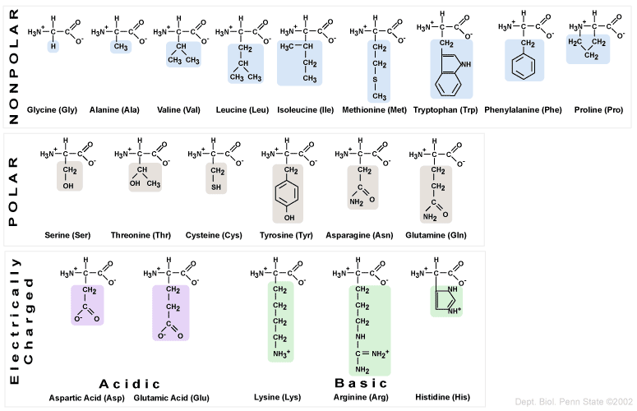

**The 20 common α-amino acids**

**(Shown as zwitterions, see explanation below)**

**Note:**

**Amino acids can be classified according to differences in the side chain.**

Non-Polar Amino Acids have equal number of amines, carboxyl groups, and a non-polar neutral side chain. Their side chains are hydrophobic (don’t interact with water)

Polar amino acids have a neutral, but polar side chain, allowing these amino acids to participate in hydrogen bonding in the protein structure. Their side chains are hydrophilic (interact with water)

Electrically Charged Amino Acids

* Three amino acids have basic side chains, due to the presence of extra amine functional group/s. (NB amide functional groups are relatively neutral)
* There are two amino acids with acidic side chains, due to the presence of the carboxylic functional group.
* All acidic and basic amino acids have polar, hydrophilic side chains.

Recommended Video: [Classification of amino acids | Khan Academy](https://www.youtube.com/watch?v=OPAvXQsPCqQ)

## **Zwitterions**

Amino acids have high melting points and are a solid crystalline substance when pure. However, because of the polar amino and carboxyl functional groups, amino acids can form hydrogen bonds with water molecules and are soluble in water.

When dissolved in water, there is a transfer of protons between amino acids:

* the –NH2 group can act as a base, accepting a proton to become a –NH3+ group, and
* the –COOH group can act as an acid, donating a proton to become a –COO− group.

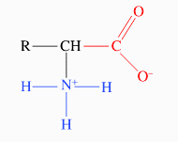As a result, an amino acid molecule in an aqueous solution is in the form +H3N–CH(R)–COO−. Such a neutral molecule is shown right and is called a zwitterion or dipolar ion.

**Zwitterions in acids and bases**

If the solution is not neutral, the zwitterion may react with the H+ or OH- ions and form different chemical forms of the amino acid. As the table below shows, the charge on the amino acid depends on the solution's pH.

| **Low pH (acidic conditions)** |  | **Intermediate pH (neutral conditions)** |  | **High pH (basic conditions)** |
| --- | --- | --- | --- | --- |
| +H3N–CH(R)–COOH | ⇌ | +H3N–CH(R)–COO− | ⇌ | H2N–CH(R)–COO− |
| Cation (+ve ion) |  | uncharged zwitterion (dipole ion) |  | Anion (-ve ion) |

## The neutral zwitterion can be changed to one of the charged (cation, anion) forms by the addition of an acid or base:

Zwitterions are a type of **amphoteric** substance. They can function as an acid (proton donor) in a base and can function as a base (proton accepter) when in an acid.

Unlike simple amphoteric substances they can function as an acid and base at the same time in neutral conditions.

Cation





Anion

Zwitterion

## **Dipeptides, Tripeptides and Polypeptides**

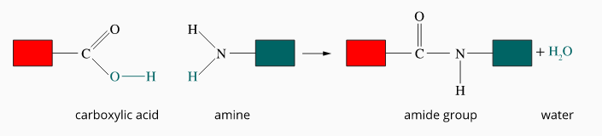When a molecule that contains a carboxyl group, –COOH, joins to a molecule comprising an amino group, –NH2, an amide functional group, –CONH–, that links the two molecules are produced. A molecule of water is also produced. This process has already been examined in the formation of polyamide polymers.

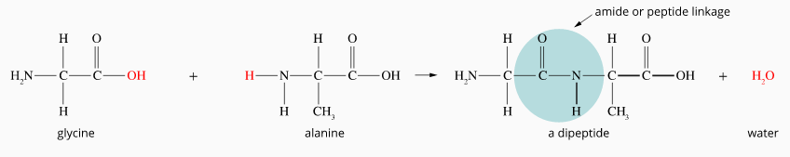  
Since amino acids have both of the required functional groups, amino acids can form amide bonds by reacting with other amino acids. When two amino acids react, an amide group called a peptide group (or peptide bond or peptide linkage) is formed that links the molecules together. Molecules made from amino acids are often called 'peptides'. When two amino acid molecules react, the product is called a dipeptide.

Gly + Ala

Gly–Ala

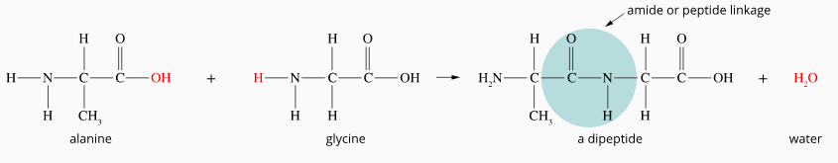Each time a pair of different amino acids react in this way, two possible product molecules are formed, depending on which ends of each molecule react together.

Ala–Gly

Ala + Gly

When three amino acid molecules react together, a tripeptide is formed. Polypeptides are polymers formed by condensation polymerisation of many amino acids. A polypeptide constructed from over 50 amino acids is usually called a protein.

## **Naming Polypeptides**

A shorthand notation is often used to describe the amino acid sequence in a polypeptide, using three-letter abbreviations.

The polypeptide would be named as Ala–Glu–Gly–Cys–Leu–Lys.

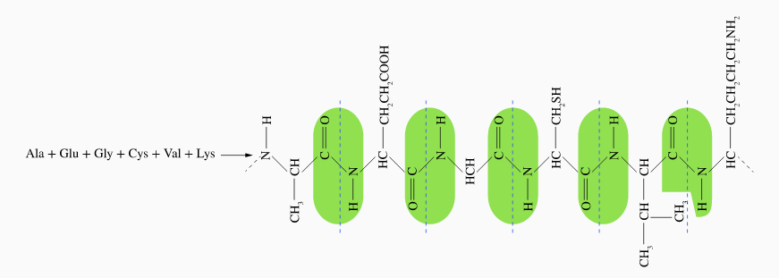

The polymerisation process results in side chains being present in every third atom of the molecule.

# **Terminal Groups**

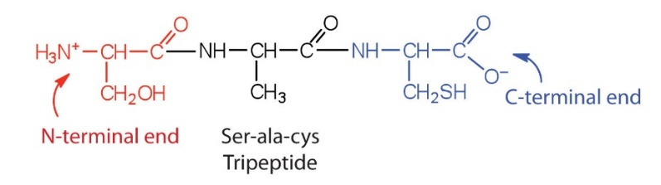Each polymer ends in a free amino (NH2) group at one end, called the **N-terminal**, and a free carboxyl (COOH) group at the other, called the **C-terminal**. By convention, amino acid polymers are named from N to C terminals (left to right)

# **Protein Structure**

## **Primary Structure**

* The protein's primary structure is the number, type, and sequence of the amino acids in a protein.
* 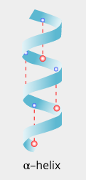The ends of the protein (polypeptide) consist of an N-terminal (free amine group –NH2) and a C – C-terminal (free carboxyl group –COOH). The structure of a protein is written from left to right, starting with the N- N-terminal and ending with the C-terminal.
* Protein sequencing is a complex technique to determine the amino acid sequence of a polypeptide.

## **Secondary Structure**

* 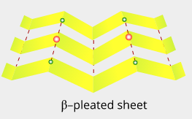Secondary structure refers to the general internal arrangement of the polypeptide chain.
* Hydrogen bonds can regularly form between the polar –N–H group in one peptide link and the polar –C=O group in another. These can result in the coiling and pleating of sections of a protein molecule to produce a secondary level of structure in a protein.
* Two basic secondary structures are produced:
* α‐helix: the molecule can coil into a spiral shape or
* β‐pleated sheets: sections line up parallel to each other.

## **Tertiary Structure**

* The overall three-dimensional shape adopted by a protein molecule is called its [tertiary structure](http://lightbook.pearsonplaces.com.au/CH12_WA/units/CH12_WA-U04/chapters/CH12_WA-U04-13/modules/CH12_WA-U04-13-04/pages/Psec04282015234349205180/topics/Tsec07202015163751067603#sec06092015161710810348).
* A tertiary structure is produced by the three-dimensional folding of its secondary structures (α-helices and β-pleated sheets) and twisting back over itself to create intricate and unique shapes responsible for the protein's function.
* Interactions between the side chains of the amino acid residues making up the polypeptide chain of a protein molecule influence the overall three-dimensional shape of the molecule.

## **Possible side-chain interactions**

| **Force Type** | **Type of R-group involved** |
| --- | --- |
| hydrogen bonds | those containing –O–H, –C=O, and – N-H are those that can form hydrogen bonds |
| dipole-dipole interactions | those containing –S–H, –O–H or –N–H |
| ionic interactions | one containing –NH3+ and another group that contains –COO− |
| covalent cross-links | cysteine side groups react to form a [disulfide bridge](http://lightbook.pearsonplaces.com.au/CH12_WA/units/CH12_WA-U04/chapters/CH12_WA-U04-13/modules/CH12_WA-U04-13-04/pages/Psec04282015234349205180/topics/Tsec07202015163751067603#sec06102015143834645226)(–S–S–) |
| dispersion forces/hydrophobic interactions | non-polar R-groups. Hydrophobic (non-polar) side chains fold to be located towards the core of the protein, away from the water. They then form dispersion forces with other non-polar amino residues. |

